Transit Deserts in the Dublin Region
A GTFS-Based Multimodal Accessibility and Transport-Equity Analysis of the Contemporary Public Transport Network
Bubuya Zelembu Dube
Civil & Railway Engineer | MSc Railway Engineering (Distinction)
August 2026

Abstract
Public transport accessibility is not determined by proximity to a bus stop or railway station alone. It depends on whether people can reach meaningful destinations within reasonable travel times and whether the resulting level of access is adequate for populations with limited alternatives to private transport. This study applies a demand–supply 'transit desert' framework to the Dublin Region using open, reproducible spatial and timetable data. The analysis combines Transport for Ireland (TFI) General Transit Feed Specification (GTFS) data, Census 2022 Small Area Population Statistics, Small Area boundaries, the Pobal HP Deprivation Index and an OpenStreetMap pedestrian network.
A multimodal graph was constructed by integrating scheduled public transport with walking links. Travel times were calculated from Small Area origins to six major employment clusters for a representative Wednesday AM peak. Transport need was proxied by the proportion of households without access to a private car, while accessibility was represented by the inverse of travel time to the nearest employment cluster. A percentile-based demand–supply classification and continuous Desert Severity Index were then used to identify areas where relatively high transport need coincides with relatively poor accessibility.
Of 5,076 Small Areas in the study extent, 4,926 (97.0%) were classifiable. Of these, 854 (17.3%), containing an estimated 233,825 residents, were classified as employment-access transit deserts. Desert status was significantly associated with Pobal deprivation category (χ² = 214.49, p < 0.001), while the continuous association with the deprivation score was modest (Pearson r = −0.190; Spearman ρ = −0.163; p < 0.001). This indicates that socioeconomic deprivation and transport disadvantage overlap but should not be treated as interchangeable constructs.
Three recurring spatial mechanisms emerge from the analysis: inner/suburban orbital gaps, destination-end last-mile gaps, and peripheral accessibility deficits. The results also show why station proximity can be misleading: several areas with direct DART access exhibit poor door-to-door accessibility because the final connection to a major employment destination requires an additional transfer. The study therefore argues for accessibility measures that account for the complete journey, temporal service characteristics and the distribution of transport need. The findings provide a reproducible baseline for evaluating transport-equity impacts of future network and service changes in Dublin.

Keywords
Public transport accessibility; transit deserts; transport equity; transport disadvantage; GTFS; GIS; multimodal network; Dublin; BusConnects; spatial analysis; transport poverty.

1. Introduction
Transport systems influence much more than how quickly people move. They determine which jobs, schools, healthcare facilities, social opportunities and public services can realistically be reached within the constraints of everyday life. For this reason, accessibility has become a central concept in transport geography and planning. Hansen's (1959) early formulation treated accessibility as the potential of opportunities for interaction, while subsequent work has distinguished accessibility from mobility and emphasised the joint influence of transport, land use, temporal constraints and individual characteristics (Geurs & van Wee, 2004; Geurs & van Wee, 2023).
This distinction matters for transport equity. A neighbourhood can have frequent buses and still offer poor access to employment if the relevant destinations require long transfers. Conversely, an area with relatively few routes may perform adequately if a high-capacity service provides direct access to a large set of opportunities. Accessibility is therefore an outcome of the relationship between people, transport services and destinations, rather than a property of infrastructure alone (Páez et al., 2012; El-Geneidy & Levinson, 2006).
The concept of a transit desert provides a particularly useful way of translating this broader accessibility problem into a spatial demand–supply question. Jiao and Dillivan (2013) describe transit deserts as locations where public transport provision is inadequate relative to the needs of populations more dependent on public transport. Currie (2010) similarly demonstrated that spatial gaps in public transport provision can be identified by explicitly comparing service supply with social need. These approaches differ from simply mapping areas with long travel times because they recognise that the same level of service does not have the same social significance everywhere.
Dublin provides a timely case for such an analysis. The public transport network has changed materially through the Luas Cross City opening and the phased BusConnects network redesign. A contemporary assessment therefore needs to reflect the network actually available to residents rather than relying exclusively on pre-redesign evidence. At the same time, the city has an established literature on deprivation and employment accessibility. Ahern, Vega and Caulfield (2016) found a relationship between transport disadvantage, deprivation and employment accessibility in Dublin, with particular vulnerability in newer peripheral suburbs. The present study builds on that work while changing the unit of analysis, the data architecture and the conceptual emphasis.
The research asks four related questions:
- Where are the spatial mismatches between transport need and public transport accessibility across the Dublin Region?
- How extensive is the population exposed to these mismatches?
- How are transit-desert classifications associated with area-level deprivation?
- What distinct spatial mechanisms appear to underlie the observed deficits?
The contribution is deliberately practical as well as academic. The study develops an open-data workflow that can be rerun as the network changes and that can be extended from employment to other essential destinations. This is important because accessibility is inherently dynamic. A classification produced from one timetable should not be interpreted as a permanent characteristic of a neighborhood.

2. Study Area
The study area is the Dublin Region, defined here as the four local authority areas of Dublin City, Fingal, South Dublin and Dún Laoghaire–Rathdown. The terminology is intentional. The administrative Dublin Region is narrower than the wider Greater Dublin Area (GDA), which contains additional counties. Unless otherwise stated, 'Dublin Region' is therefore used throughout this paper to describe the analytical extent.
The study contains 5,076 Census 2022 Small Areas covering approximately 926 km². Small Areas provide substantially finer spatial resolution than Electoral Divisions and are consequently better suited to identifying within-city variation in accessibility. Fine-grained spatial units are valuable in equity analysis because aggregation can conceal localised disadvantage and can materially affect conclusions about the relationship between socioeconomic characteristics and accessibility (Talen & Anselin, 1998; Fotheringham & Wong, 1991).
Dublin's spatial structure is analytically useful because the region combines a dense central employment area, mature inner suburbs, suburban employment centres and lower-density peripheral settlements. These different urban forms can produce different accessibility mechanisms. A peripheral settlement may experience long travel times because of distance and service frequency, whereas a centrally located neighbourhood may experience a deficit because of weak orbital connectivity or an inconvenient transfer at the destination end.

3. Conceptual and Literature Framework

3.1 Accessibility as an outcome rather than a facility measure
Accessibility has been defined and operationalised in many ways. Geurs and van Wee (2004) identify four broad components: land-use, transport, temporal and individual components. Their framework is useful here because the present analysis captures transport and temporal conditions reasonably well but simplifies land-use opportunity and individual characteristics. The limitation is therefore not hidden; it is part of the interpretation of the resulting measure.
Place-based accessibility measures can be cumulative, gravity-based or utility-based. Cumulative measures count opportunities reachable within a specified travel-time threshold, while gravity-type measures apply distance decay and utility-based measures incorporate generalised costs and preferences (El-Geneidy & Levinson, 2006; Páez et al., 2012). There is no universally superior metric. More sophisticated measures can capture more dimensions of accessibility but require more assumptions and data. For a reproducible open-data transit-desert screening framework, a transparent travel-time measure has the advantage of being straightforward to audit and communicate.
The present study therefore uses minimum multimodal travel time to a set of major employment clusters. This is best interpreted as a screening measure of destination accessibility, not as a comprehensive measure of all employment opportunities. The distinction is important and is revisited in the limitations.

3.2 Transport disadvantage, social exclusion and justice
Transport disadvantage has long been linked to social exclusion. Lucas (2012) argues that transport disadvantage can restrict access to employment, education, healthcare and social participation, thereby reinforcing wider forms of exclusion. Lucas et al. (2008) and Stanley and Lucas (2008) similarly emphasise that transport policy should consider the social consequences of unequal access rather than treating mobility as an end in itself.
More recent transport-justice scholarship places accessibility at the centre of distributive questions. Pereira, Schwanen and Banister (2017) argue that transport equity should be considered in terms of people's opportunities and capabilities to reach valued destinations. Martens (2016) develops a normative framework for transport justice in which minimum levels of accessibility and the distribution of benefits and burdens become central policy concerns. This study does not claim to establish a normative threshold of justice; instead, it uses a relative demand–supply classification to identify locations that merit closer investigation.
This distinction is important because a statistical 'transit desert' is not automatically a policy prescription. A classification identifies a spatial condition. Determining whether the condition is unacceptable, why it occurs and which intervention is appropriate requires additional evidence, including service reliability, affordability, safety, walking conditions, land-use opportunity and the characteristics of affected populations.

3.3 Transit deserts and public transport supply–need mismatch
Jiao and Dillivan (2013) formalised the transit-desert idea as a comparison between transit supply and transit-dependent populations. Currie (2010) developed a related approach for Melbourne, explicitly quantifying gaps between public transport supply and social need. These studies are particularly relevant because they caution against interpreting service supply without reference to who is being served.
Chen and Jiao (2022) extended the transit-desert framework to European metropolitan cases using publicly available data. Their work demonstrates that the concept can be transferred across institutional contexts, while also showing that results depend strongly on how demand and supply are operationalised. That observation motivates the explicit documentation of thresholds and proxy variables in the present Dublin study.
Murray (2001) and Mavoa et al. (2012) provide further support for considering coverage, service frequency and walking access jointly. Mavoa et al. (2012), in particular, demonstrated the value of combining public transport and walking accessibility rather than evaluating transit as a purely route-based service. The present study follows this principle by connecting GTFS stops to an OSM pedestrian network.

3.4 First- and last-mile accessibility
The first and last legs of a public transport journey can materially alter the accessibility of a trunk service. Mavoa et al. (2012) included walking within the public transport journey, while Oeschger, Carroll and Caulfield (2023) examined first- and last-mile connections in Dublin and reported user concerns about walking conditions and access/egress. This literature supports a door-to-door perspective in which a rail station cannot be treated as the destination simply because a high-capacity service reaches it.
The Dún Laoghaire–Sandycove result in this study illustrates this point particularly clearly. The DART segment itself is efficient, but the journey to the selected employment destination requires an additional connection at the Dublin end. A station-proximity metric would miss this problem.

3.5 Accessibility to essential services
Employment is an important destination because access to work is closely connected to economic opportunity, but it is not the only destination that matters. Healthcare accessibility research has developed extensive spatial measures ranging from travel time to more sophisticated supply–demand methods (Luo & Wang, 2003; McGrail & Humphreys, 2014). Multi-purpose accessibility studies likewise show that accessibility can vary considerably depending on the destination category being examined.
This motivates a future extension of the Dublin framework to healthcare, education, retail and public services. Such an extension would also allow the study to test whether employment-access deserts are persistent across daily activities or whether they are destination-specific. The distinction is important for policy: a neighbourhood that is poorly connected to jobs but well connected to schools and healthcare faces a different problem from one with consistently poor access across essential destinations.

3.6 Spatial equity and the modifiable areal unit problem
Spatial equity findings depend partly on the scale and geography used for analysis. Talen and Anselin (1998) showed that different accessibility measures can lead to different conclusions about the equity of urban services. Openshaw (1984) and Fotheringham and Wong (1991) established the broader methodological problem associated with the modifiable areal unit problem (MAUP). The use of Small Areas reduces aggregation relative to Electoral Divisions but does not eliminate spatial-scale effects.
This issue is particularly relevant to the present equity analysis because accessibility is calculated at Small Area level while the openly available Pobal deprivation measure used here is at Electoral Division level. The relationship between the two should therefore be interpreted as an area-level association, not as evidence about individual households.

4. Research Gap and Contribution
The literature supports a clear but carefully bounded research gap. Dublin has established research on transport disadvantage and employment accessibility, but there is value in updating the analysis to contemporary network conditions and finer spatial units. The present study contributes in five ways.
- It applies an explicit demand–supply transit-desert framework to the Dublin Region.
- It uses contemporary GTFS schedule data rather than relying solely on static stop proximity or historical network configurations.
- It evaluates accessibility at Census 2022 Small Area level, allowing more spatially detailed analysis than Electoral Division-based studies.
- It integrates walking and public transport into a single multimodal network, thereby representing the journey rather than the transit facility alone.
- It establishes a reproducible open-data baseline that can be extended to multiple destination types and future network scenarios.
The study does not claim that these characteristics make it the first or only accessibility analysis of contemporary Dublin. Rather, its contribution lies in combining these elements into a transparent, demand–supply screening framework that can be independently reproduced and updated.

5. Data and Methodology

5.1 Analytical design
The workflow comprises five stages: data preparation; multimodal network construction; accessibility calculation; demand–supply classification; and equity analysis. All calculations are spatially referenced to Census 2022 Small Areas. The principal accessibility scenario is a representative Wednesday AM peak, chosen to approximate a conventional weekday commuting period.

5.2 Data sources
Dataset | Role | Vintage / specification
TFI / NTA GTFS | Routes, stops, trips, stop times and service schedules | August 2026–August 2027 service period
CSO Census 2022 SAPS | Population and household car-availability variables | 2022
Tailte Éireann / GeoHive | Census Small Area boundaries | 2022
Pobal HP Deprivation Index | Area-level deprivation/affluence validation | 2022; Electoral Division
OpenStreetMap / Geofabrik | Pedestrian network | August 2026 extract
GTFS provides a standardised representation of scheduled public transport services, including stop locations, routes, trips and stop times. Its principal advantage for this study is that it allows accessibility to be derived from the timetable rather than from route presence alone. This is consistent with the broader accessibility literature, which emphasises that service frequency, waiting and transfer conditions influence actual accessibility (Mavoa et al., 2012).

5.3 Pedestrian network and multimodal graph
The OpenStreetMap pedestrian network contained 935,839 nodes and 1,018,009 edges. Public transport stops were snapped to the nearest walking-network node, with a median snapping distance of 8.7 m. GTFS-derived transit connections were then integrated with the walking graph. The resulting multimodal graph contained 941,229 nodes and 2,054,030 edges, with 96.4% weak connectivity.
The use of OpenStreetMap is appropriate for a reproducible research workflow because it provides broad geographic coverage and can represent pedestrian infrastructure at a fine spatial scale. At the same time, crowdsourced network data introduce potential completeness and topology problems. The 147 Small Areas that fell on disconnected pedestrian components are treated as missing-data cases rather than being assigned artificially favourable or unfavourable accessibility.

5.4 Temporal service representation
Service headways and expected waiting times were calculated for five time periods. The principal reported scenario uses a representative Wednesday AM peak. Expected waiting is treated as a function of service frequency rather than as a fixed penalty. This is preferable to assuming that a passenger arrives at a station at an exact scheduled departure time, although it remains a simplification because it does not model service unreliability or passenger-specific arrival behaviour.
The analysis also recognises that accessibility is time-dependent. A network can provide adequate commuting access while providing weak evening or weekend access. Consequently, the AM peak results should not be interpreted as a complete representation of the daily accessibility experience.

5.5 Origins, destinations and routing
Each Small Area was represented by its geometric centroid. The original analytical concept considered population-weighted centroids, but open data did not provide sufficiently detailed intra-Small-Area population distributions to support a defensible weighting procedure. The final analysis therefore uses geometric centroids consistently. This distinction is now stated explicitly to avoid ambiguity.
Travel time was calculated from each origin to six major employment clusters: Dublin City Centre/CBD, IFSC/Docklands, Sandyford Business District, Dublin Airport, Blanchardstown and Tallaght. Single-source Dijkstra searches on a reversed network were used to efficiently calculate travel times to all origins for each destination.
The destination representation is intentionally conservative. The six clusters are proxies for major employment concentrations rather than a complete jobs surface. The measure therefore answers the question 'how readily can residents reach a major employment cluster?' rather than 'how many jobs can residents reach?' A jobs-weighted opportunity measure would be preferable if sufficiently detailed workplace data were available.

5.6 Operationalising transport need
Transport need is represented by the proportion of households without access to a private car. This is a practical proxy for potential dependence on public transport because households without private vehicles have fewer motorised alternatives. However, the variable should not be interpreted as a direct measure of individual transport dependency. It does not capture licensing, vehicle availability by time of day, disability, income, trip purpose or the characteristics of individual household members.

5.7 Accessibility measure
For Small Area i, let T_i denote the minimum multimodal travel time to the six employment clusters. Accessibility is represented by A_i = 1/T_i, so that higher values indicate better accessibility. The use of inverse travel time preserves the ordering of locations while keeping the measure simple and interpretable.
This is a deliberately parsimonious measure. It does not incorporate destination attractiveness, job counts, fares, crowding or reliability. Its role is to provide a transparent accessibility dimension that can be compared with transport need.

5.8 Transit-desert classification
Need and accessibility were converted to percentile ranks. The median of each distribution was then used to create a 2 × 2 classification. Areas above the median on need and below the median on accessibility were classified as transit deserts. The continuous Desert Severity Index was calculated as the difference between need percentile and accessibility percentile.
The median split is useful for exploratory screening because it is transparent and avoids arbitrary absolute thresholds. It is not, however, a normative definition of inadequate service. A relative classification means that the number of deserts depends partly on the study population and the selected threshold. For this reason, the continuous severity index is retained and sensitivity testing is recommended before policy thresholds are adopted.

5.9 Statistical analysis
A chi-square test of independence was used to examine whether desert status differed across Pobal deprivation categories. Pearson and Spearman correlations were calculated between the continuous severity index and the Pobal deprivation score. Because the observations are spatially located, the inferential results are interpreted cautiously: statistical significance does not imply causality and does not remove the possibility of spatial dependence.
A further methodological refinement for subsequent publication would be a spatial-autocorrelation test, such as Moran's I, followed by spatially explicit modelling if the objective is to estimate independent predictors of desert severity. The present analysis is intentionally descriptive and diagnostic rather than causal.

6. Results

6.1 Overall classification
Of the 5,076 Small Areas, 4,926 (97.0%) had valid accessibility and Census inputs and were therefore classifiable. A total of 854 Small Areas, equivalent to 17.3% of the classifiable set, were classified as transit deserts. These areas contain an estimated 233,825 residents.
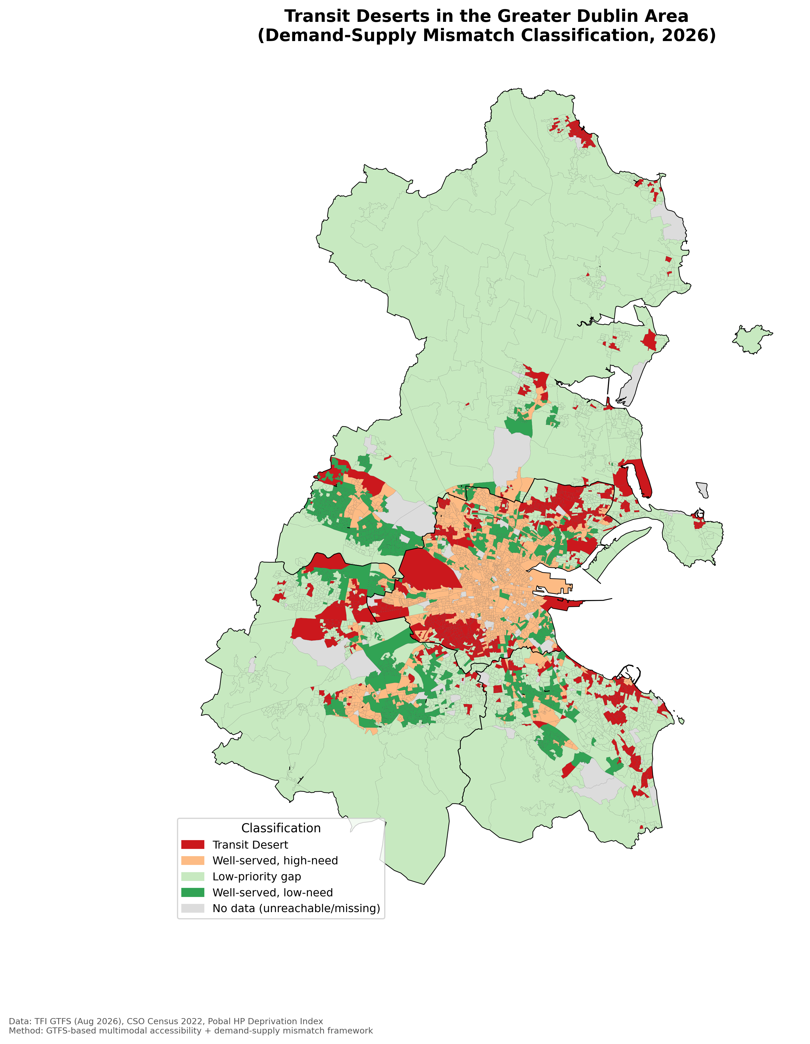
Figure 1. Transit-desert classification across the Dublin Region. The classification identifies locations with relatively high transport need and relatively low employment accessibility.

6.2 Spatial severity
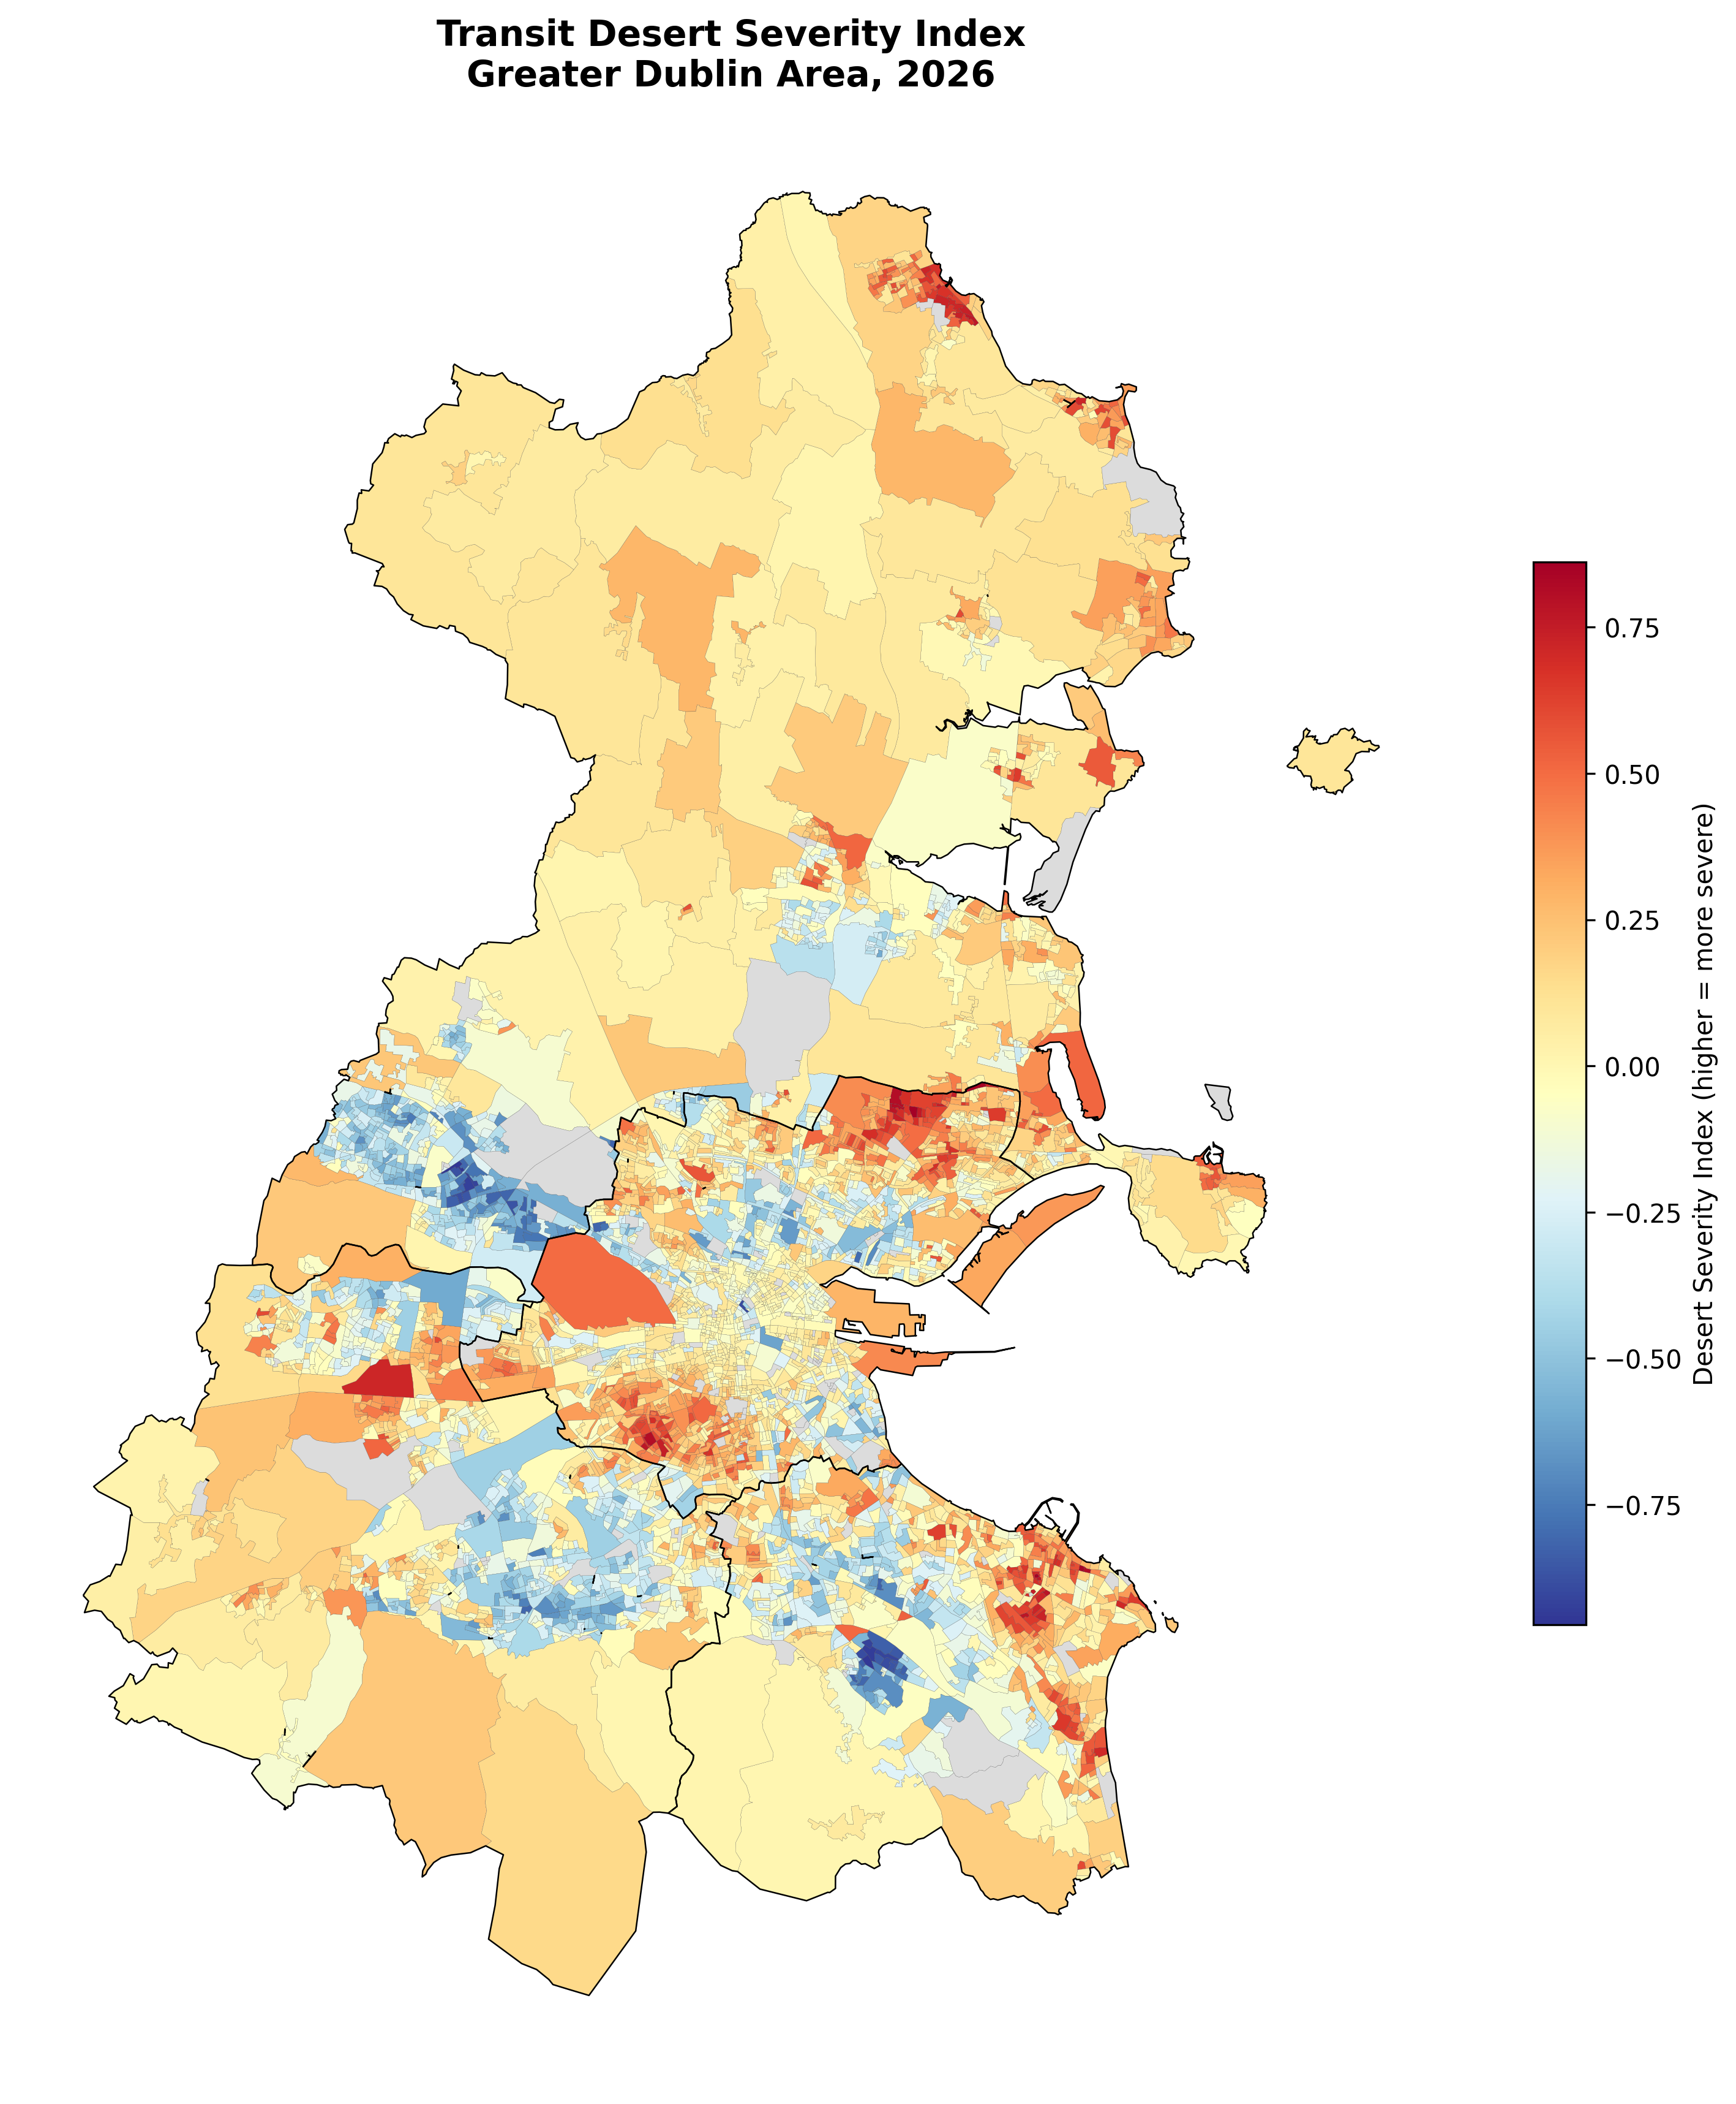
Figure 2. Continuous Desert Severity Index. Higher values indicate a larger positive gap between percentile-ranked transport need and accessibility.
The continuous severity surface adds information that the binary classification cannot provide. Particularly visible concentrations occur in north Fingal and the north-east inner city, including Priorswood. The pattern is not simply a radial distance effect: severe locations also occur within relatively central parts of the metropolitan area.

6.3 Underlying demand and accessibility
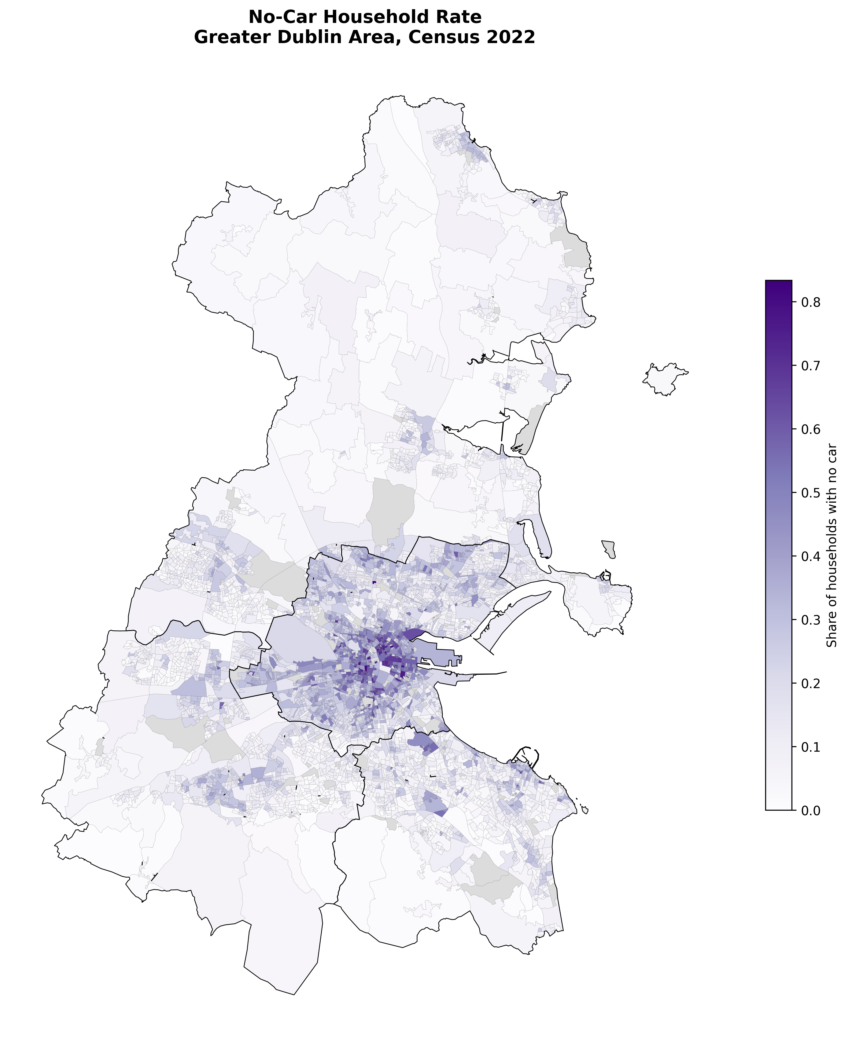
Figure 3. Household no-car rate used as the transport-need proxy. The distribution reflects the combined influence of density, household structure and car availability.
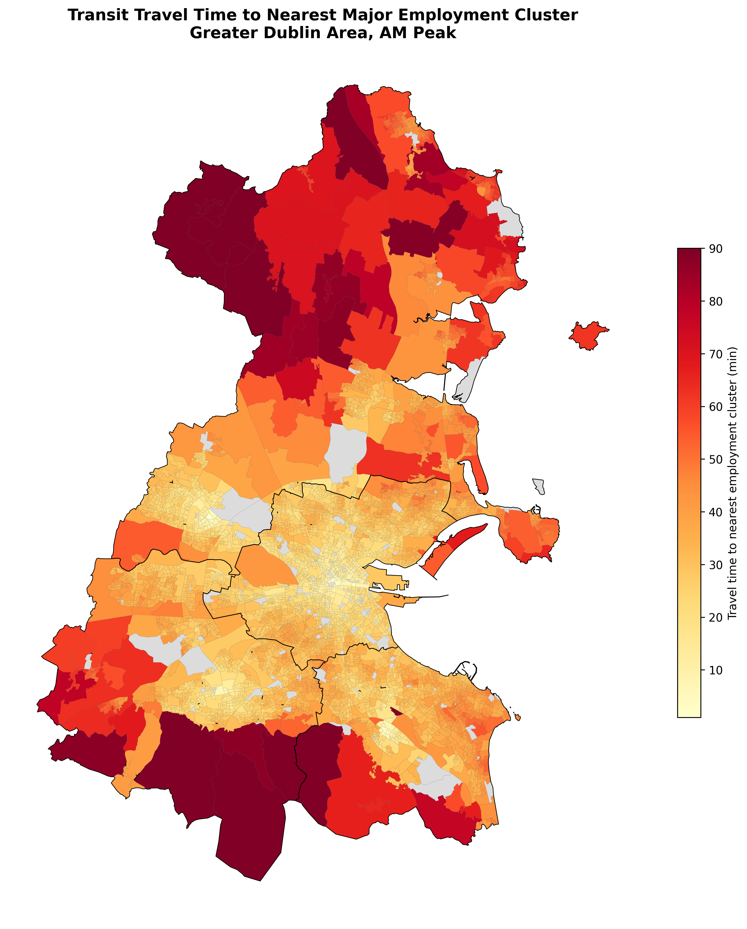
Figure 4. Multimodal travel time to the nearest major employment cluster during the representative Wednesday AM peak.
The two underlying surfaces should be interpreted together. High no-car rates indicate greater potential dependence on public transport, but they do not by themselves establish poor accessibility. Likewise, long travel times do not necessarily constitute a transport-equity problem if alternative travel options are widely available. The transit-desert framework is designed to identify the overlap.

6.4 Equity association
Desert status is significantly associated with Pobal deprivation category (χ² = 214.49, p < 0.001, df = 4). The proportion of Small Areas classified as deserts is highest in the disadvantaged categories: 32.3% in the 'Very Disadvantaged' group and 37.0% in the 'Disadvantaged' group, compared with 12.2% among 'Marginally Above Average' areas and 13.5% among 'Affluent' areas.
Pobal category | Non-desert SAs | Desert SAs | % Desert
Very Disadvantaged | 42 | 20 | 32.3%
Disadvantaged | 254 | 149 | 37.0%
Marginally Below Average | 751 | 250 | 25.0%
Marginally Above Average | 2134 | 296 | 12.2%
Affluent | 891 | 139 | 13.5%
The continuous relationship is modest: Pearson r = −0.190 and Spearman ρ = −0.163, both p < 0.001. The Pobal score is coded so that higher values indicate greater affluence; the negative relationship therefore indicates that greater desert severity tends to occur in more disadvantaged areas. The effect is not large, however, which is substantively important. It indicates that deprivation is related to transport disadvantage but is not an adequate substitute for an accessibility-based measure.

6.5 Electoral Divisions with complete desert classification
Electoral Division | Local authority | Small Areas | Pobal category
Priorswood B | Dublin City | 7 | Very Disadvantaged
Priorswood C | Dublin City | 16 | Disadvantaged
Priorswood D | Dublin City | 9 | Disadvantaged
Kimmage B | Dublin City | 14 | Marginally Below Average
Kimmage A | Dublin City | 7 | Marginally Below Average
Kimmage D | Dublin City | 10 | Marginally Above Average
Kilmore B | Dublin City | 11 | Disadvantaged
Kilmore C | Dublin City | 4 | Disadvantaged
Cherry Orchard A | Dublin City | 5 | Disadvantaged
Crumlin E | Dublin City | 10 | Marginally Below Average

7. Spatial Case Studies

7.1 Priorswood: accessibility and deprivation converging
Priorswood provides the clearest example of overlapping transport and socioeconomic disadvantage. Priorswood B, C and D contain 32 Small Areas, all classified as transit deserts. Two of the three Electoral Divisions fall within the 'Very Disadvantaged' or 'Disadvantaged' Pobal categories. Modelled travel times to Dublin City Centre range from approximately 42 to 49 minutes.
The result does not, by itself, demonstrate that a new bus route is the optimal intervention. The network should first be diagnosed to determine whether the limiting factor is local coverage, service frequency, transfer penalties, walking access or cross-suburban connectivity. This is where the analytical value of the desert framework becomes practical: it identifies a location for investigation but does not prescribe an intervention without a network-level diagnosis.

7.2 Dún Laoghaire–Sandycove/Glenageary: the destination-end problem
The Dún Laoghaire–Sandycove/Glenageary cluster is one of the most instructive findings because it challenges a common assumption in accessibility mapping. Several Small Areas record severe desert scores despite direct DART access. Path tracing indicates that the rail component is efficient—approximately 20 minutes in-vehicle with a short expected wait—while the onward connection to the IFSC/Docklands introduces an additional transfer.
This case demonstrates why proximity to a high-capacity trunk service is not equivalent to door-to-door accessibility. It also reinforces the first/last-mile literature, which argues that access and egress are integral parts of the public transport journey (Mavoa et al., 2012; Oeschger et al., 2023).

7.3 Kimmage: a central-area orbital gap
Kimmage A, B and D have complete desert classification, with travel times of approximately 38–41 minutes to the nearest selected employment clusters. Their relatively central position makes a simple peripheral-distance explanation insufficient. The pattern is more consistent with an orbital or cross-city connectivity problem, although route-level intervention analysis would be required before making a definitive operational diagnosis.

7.4 Balbriggan Rural: peripheral accessibility
Balbriggan Rural represents a different mechanism. Travel times exceed approximately 56 minutes to the nearest selected employment cluster, consistent with the area's position towards the northern edge of the analytical region. Here, distance, service frequency and the regional structure of employment opportunities are likely to be more important than the local orbital topology seen in Kimmage or Priorswood.

8. Discussion
The central finding is that Dublin's transit deserts are heterogeneous. The analysis does not reveal a single 'underserved Dublin'; it reveals different forms of mismatch between transport need and accessibility. This distinction is important because interventions that address one mechanism may have little effect on another.
The first mechanism is an inner/suburban orbital gap, evident in locations such as Priorswood and Kimmage. These areas can be relatively close to central Dublin in geographic terms yet experience poor multimodal access to major employment clusters because the network does not provide sufficiently direct or frequent cross-suburban connections. This finding is consistent with the broader literature showing that accessibility depends on network structure and not simply Euclidean distance (Geurs & van Wee, 2004; Mavoa et al., 2012).
The second mechanism is a destination-end last-mile gap. The Dún Laoghaire example demonstrates that strong trunk-line performance can coexist with poor door-to-destination accessibility. This is particularly relevant in a metropolitan network where major employment clusters are concentrated in areas served by multiple modes but where interchange between those modes may still impose time penalties.
The third mechanism is peripheral accessibility disadvantage. Balbriggan Rural and parts of northern Fingal experience a different geography, where distance to major opportunities and the frequency of regional connections are more fundamental constraints. This is broadly consistent with Dublin evidence from Ahern et al. (2016), who identified vulnerability to transport poverty in peripheral areas.
The equity result is equally important. The significant chi-square statistic indicates that desert status is not independent of deprivation category. Yet the modest correlation shows that deprivation and transport accessibility are not the same phenomenon. This supports a more nuanced understanding of transport justice. A deprivation-only approach could overlook areas where residents have relatively high socioeconomic resources but face poor access for particular journeys. Conversely, an accessibility-only approach could identify low-access areas without establishing whether residents have viable alternatives.
This distinction also matters for policy evaluation. Pereira et al. (2017) argue that transport equity should be understood in terms of people's opportunities and capabilities, while Martens (2016) places minimum accessibility and distributional effects at the centre of transport justice. The present analysis is not a normative justice test, but it provides a practical screening mechanism that could support such a test if policymakers establish explicit accessibility standards.
The study also illustrates a broader methodological point: accessibility measures are sensitive to how the journey is represented. A station-density map, a straight-line catchment or a route-count measure would likely classify some DART-served locations as well served. The multimodal shortest-path approach instead exposes the transfer and destination effects that occur between the origin and the final opportunity.
Finally, the analysis should not be read as evidence that BusConnects has caused or failed to cause transport disadvantage. The study is cross-sectional and does not provide a before-and-after counterfactual. A stronger causal evaluation would require historical GTFS/network data, comparable socioeconomic conditions and an explicit pre/post identification strategy.

9. Implications for Transport Planning

9.1 Targeted network diagnosis
- For inner/suburban deserts, test orbital and feeder alternatives, frequency improvements and transfer reductions before assuming that additional radial capacity is required.
- For destination-end gaps, examine interchange and final-connection travel time. The relevant intervention may be a local circulator, better bus coordination, walking infrastructure or improved interchange rather than additional trunk capacity.
- For peripheral deserts, assess regional service frequency, span of service and connectivity to multiple employment centres rather than focusing solely on local stop coverage.

9.2 Equity-oriented appraisal
The results could be integrated into future accessibility appraisal by identifying whether proposed network changes disproportionately improve access in high-need areas. This aligns with the direction of contemporary transport-equity research, which increasingly treats accessibility as an outcome to be distributed rather than travel-time savings as the sole measure of benefit.

9.3 Monitoring a changing network
Because GTFS feeds are time-specific, the workflow can be rerun after timetable or network changes. This makes it potentially useful as a monitoring framework: the question is not only where deserts exist today, but whether network changes reduce the number, severity and population exposure of deserts over time.

10. Limitations and Robustness Requirements
Several limitations should be kept visible because they define the boundaries of the conclusions.
- Employment destination representation: the six destination clusters are proxies, not a complete jobs-weighted employment surface. The results should therefore be described as accessibility to selected major employment clusters.
- Need proxy: household no-car rate is a defensible but imperfect indicator of potential public transport dependence. It should not be interpreted as individual-level transit dependency.
- Spatial mismatch in equity data: accessibility is calculated at Small Area level, whereas the open Pobal measure used here is at Electoral Division level. This prevents direct inference about individual households.
- Centroid approximation: geometric centroids may fall in locations that do not represent the actual residential distribution within a Small Area. Population-weighted origins would be preferable if suitable open data became available.
- OSM completeness: 147 Small Areas were excluded because of disconnected pedestrian components. These should be audited for missing footway links before the analysis is used for operational decisions.
- Temporal scope: Wednesday AM peak is the principal scenario. Evening, weekend and off-peak accessibility can differ materially.
- Scheduled service: the model does not include reliability, cancellation, crowding, congestion-induced delay or passenger-specific behaviour.
- Relative classification: median splits identify relative mismatch, not an absolute minimum acceptable level of service.
- No causal inference: the analysis identifies spatial association and mismatch but cannot establish that deprivation causes poor accessibility or that network supply causes deprivation.
- Spatial dependence: neighbouring Small Areas are unlikely to be statistically independent. Future inferential analysis should therefore test spatial autocorrelation and, if appropriate, use spatial regression or other spatially explicit methods.
The analysis also encountered 12 stop-period combinations with a calculated headway of exactly zero seconds, attributable to overlapping GTFS trip variants scheduled at the same minute. These cases are treated as a narrow source-data artefact and should be documented in any reproducibility package rather than silently removed.

11. Future Research
The next stage should move from a single-purpose screening analysis towards a multi-purpose, time-dependent accessibility framework.
- Extend accessibility to hospitals, primary care, schools, universities, retail centres and public services. Healthcare accessibility methods such as 2SFCA and its variants provide useful alternatives where facility capacity and population demand can be incorporated (Luo & Wang, 2003; McGrail & Humphreys, 2014).
- Replace hand-specified employment clusters with a jobs-weighted opportunity surface when suitably granular employment data are available.
- Report PM peak, evening, Saturday and Sunday results alongside the AM peak to identify temporal transit deserts.
- Run threshold sensitivity tests using alternative percentile cut-offs and compare the resulting classifications with the continuous severity index.
- Audit the 147 disconnected Small Areas and correct missing pedestrian links where appropriate.
- Add fare affordability, reliability, walking quality and accessibility for people with mobility impairments to move beyond a purely time-based measure.
- Use spatial autocorrelation diagnostics and spatial regression to investigate whether deprivation, density, car ownership, peripheral location and network structure independently explain desert severity.
- Develop before/after comparisons around BusConnects implementation phases where historical GTFS and comparable population data can be assembled.
- Evaluate proposed route or frequency interventions by rerunning the network model under alternative scenarios, thereby moving from descriptive mapping towards decision support.
A particularly promising extension is to create a composite 'multi-purpose accessibility stress' measure that identifies locations where low access persists across several essential destination types. Such a measure should be kept distinct from the employment-only desert classification rather than replacing it.

12. Conclusion
This study provides a reproducible, open-data framework for examining transport accessibility and demand–supply mismatch in the Dublin Region. Using contemporary GTFS schedules, Census 2022 Small Areas, an OpenStreetMap walking network and the Pobal deprivation index, the analysis identifies 854 Small Areas as employment-access transit deserts, representing an estimated 233,825 residents.
The result is important not because 854 is a definitive count of people experiencing transport poverty, but because it demonstrates how a demand–supply framework reveals patterns that conventional infrastructure-proximity measures can miss. The statistically significant but modest relationship with deprivation is particularly informative: social disadvantage and transport disadvantage overlap, but neither can be used as a substitute for the other.
The spatial case studies point to three recurring mechanisms—inner/suburban orbital gaps, destination-end last-mile gaps and peripheral accessibility deficits. Each requires a different planning response. The Dún Laoghaire–Sandycove case is especially instructive because it shows that a well-served rail corridor can still generate poor door-to-door accessibility when the final connection is weak.
The study should therefore be viewed as a baseline rather than an endpoint. Its strongest contribution is methodological: it creates a transparent framework that can be rerun, challenged and extended as Dublin's public transport network changes. With multi-purpose destinations, reliability, affordability, spatially explicit equity modelling and scenario testing added, the framework could support a more comprehensive assessment of transport justice and accessibility in the Dublin metropolitan region.

References
Ahern, A., Vega, A., & Caulfield, B. (2016). Deprivation and access to work in Dublin city: The impact of transport disadvantage. Research in Transportation Economics, 57, 44–52. https://doi.org/10.1016/j.retrec.2016.06.009
Allen, J., Muñoz, J. C., & Rosell, J. (2019). Effect of transportation accessibility on social exclusion: A comparison between public and private transport. Transportation Research Part A, 126, 1–17.
Ben-Akiva, M., & Lerman, S. R. (1985). Discrete Choice Analysis: Theory and Application to Travel Demand. MIT Press.
Boisjoly, G., & El-Geneidy, A. M. (2017). How to get there? A critical assessment of accessibility objectives and indicators. Transport Reviews, 37(4), 465–486.
Chen, Y., & Jiao, J. (2022). Are there transit deserts in Europe? A study focusing on four European cases through publicly available data. Sustainability, 14(20), 13182. https://doi.org/10.3390/su142013182
Church, A., Frost, M., & Sullivan, K. (2000). Transport and social exclusion in London: Exploring the possibility of a link. European Journal of Transport and Infrastructure Research, 0(1).
Currie, G. (2010). Quantifying spatial gaps in public transport supply based on social needs. Journal of Transport Geography, 18(1), 31–41. https://doi.org/10.1016/j.jtrangeo.2008.12.002
El-Geneidy, A. M., & Levinson, D. M. (2006). Access to destinations: Development of accessibility measures. Minnesota Department of Transportation.
Fotheringham, A. S., & Wong, D. W. S. (1991). The modifiable areal unit problem in multivariate statistical analysis. Environment and Planning A, 23(7), 1025–1044.
Geurs, K. T., & van Wee, B. (2004). Accessibility evaluation of land-use and transport strategies: Review and research directions. Journal of Transport Geography, 12(2), 127–140. https://doi.org/10.1016/j.jtrangeo.2003.10.005
Geurs, K. T., & van Wee, B. (2023). A five-component conceptual model of calculated and perceived accessibility: Literature review and research directions. Journal of Transport Geography.
Hansen, W. G. (1959). How accessibility shapes land use. Journal of the American Institute of Planners, 25(2), 73–76. https://doi.org/10.1080/01944365908978307
Jiao, J., & Dillivan, M. (2013). Transit deserts: The gap between demand and supply. Journal of Public Transportation, 16(3), 23–39. https://doi.org/10.5038/2375-0901.16.3.2
Joseph, A. E., & Bantock, P. R. (1982). Measuring potential physical accessibility to general practitioners in rural areas: A method and case study. Social Science & Medicine, 16(1), 85–90.
Kwan, M.-P. (1998). Space-time and integral measures of individual accessibility: A comparative analysis using a point-based framework. Geographical Analysis, 30(3), 191–216.
Lucas, K. (2012). Transport and social exclusion: Where are we now? Transport Policy, 20, 105–113. https://doi.org/10.1016/j.tranpol.2012.01.013
Lucas, K., Grosvenor, T., & Simpson, R. (2001). Transport, the Environment and Social Exclusion. Joseph Rowntree Foundation.
Lucas, K., van Wee, B., & Maat, K. (2016). A method to evaluate equitable accessibility: Exploring mobility and transport-related social exclusion. Transportation, 43, 1–24.
Luo, W., & Wang, F. (2003). Measures of spatial accessibility to health care in a GIS environment: Synthesis and a case study in the Chicago region. Environment and Planning B, 30(6), 865–884.
Mavoa, S., Witten, K., McCreanor, T., & O'Sullivan, D. (2012). GIS based destination accessibility via public transit and walking in Auckland, New Zealand. Journal of Transport Geography, 20(1), 15–22. https://doi.org/10.1016/j.jtrangeo.2011.10.001
Martens, K. (2016). Transport Justice: Designing Fair Transportation Systems. Routledge.
McGrail, M. R., & Humphreys, J. S. (2014). Measuring spatial accessibility to primary health care services: Utilising dynamic catchment sizes. Applied Geography, 54, 182–188.
Murray, A. T. (2001). Strategic analysis of public transport coverage. Socio-Economic Planning Sciences, 35(3), 175–188.
Oeschger, G., Carroll, P., & Caulfield, B. (2023). First- and last-mile connections to public transport in Dublin: Analysis of pre-COVID-19 mobility patterns and user experiences. Transportation Research Procedia, 72, 916–923.
Openshaw, S. (1984). The Modifiable Areal Unit Problem. Geo Books.
Páez, A., Scott, D. M., & Morency, C. (2012). Measuring accessibility: Positive and normative implementations of various accessibility indicators. Journal of Transport Geography, 25, 141–153.
Penchansky, R., & Thomas, J. W. (1981). The concept of access: Definition and relationship to consumer satisfaction. Medical Care, 19(2), 127–140.
Pereira, R. H. M., Schwanen, T., & Banister, D. (2017). Distributive justice and equity in transportation. Transport Reviews, 37(2), 170–191. https://doi.org/10.1080/01441647.2016.1257660
Shen, Q. (1998). Location characteristics of inner-city neighborhoods and employment accessibility of low-wage workers. Environment and Planning B, 25(3), 345–365.
Stanley, J., & Lucas, K. (2008). Social exclusion: What can public transport offer? Research in Transportation Economics, 22(1), 36–40.
Talen, E., & Anselin, L. (1998). Assessing spatial equity: An evaluation of measures of accessibility to public playgrounds. Environment and Planning A, 30(4), 595–613.
Welch, T. F., & Mishra, S. (2013). A measure of equity for public transit connectivity. Journal of Transport Geography, 33, 29–41.
Zhang, Y., & colleagues. (2025). Using the logsum to explore transport equity in public transport planning in Ireland. National Transport Authority / Trinity College Dublin.
Central Statistics Office. (2023). Census 2022 Small Area Population Statistics. Government of Ireland.
National Transport Authority / Transport for Ireland. (2026). GTFS static public transport schedule data. Government of Ireland Open Data.
Pobal. (2023). Pobal HP Deprivation Index 2022. Government of Ireland / Pobal.
Tailte Éireann / GeoHive. (2022). Census 2022 Small Area boundaries. Government of Ireland.
OpenStreetMap contributors. (2026). OpenStreetMap data. https://www.openstreetmap.org/copyright

Appendix A. Reproducibility and Publication Checklist
- Archive the exact GTFS feed, download timestamp and feed version/hash used for the analysis.
- Publish the Python/QGIS processing scripts or, where data licensing prevents redistribution, publish code plus precise instructions for obtaining the source datasets.
- Document all network parameters: walking speed, transfer penalties, boarding/alighting assumptions, stop snapping tolerance and treatment of service headways.
- Publish the mathematical definition of the accessibility and Desert Severity Index measures.
- Run sensitivity tests for alternative percentile thresholds and report whether the main clusters remain stable.
- Audit the 147 disconnected Small Areas before any operational or policy use.
- Test global and local spatial autocorrelation before making stronger inferential claims.
- For future versions, compare AM, PM, evening and weekend scenarios and report temporal stability of the desert classification.
- Avoid using 'transit-dependent' as a direct label for residents unless individual-level dependency is actually measured; use 'higher transport need' or 'higher potential public transport dependence' for the present proxy.
- Use 'Dublin Region' consistently for the four-authority study extent and reserve 'Greater Dublin Area' for the wider regional geography.
Data and result note: Quantitative results and site-specific findings in this paper are retained from the supplied analysis report. Methodological clarifications, literature framing and publication-oriented qualifications have been added to strengthen the interpretation without inventing new empirical results.

